These diagrams show:

1. Class Diagram:
   * All major classes with attributes and methods
   * Relationships between classes
   * Multiplicity of relationships

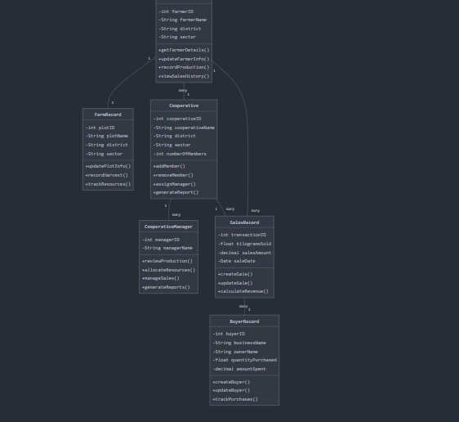

1. Activity Diagram:
   * Complete workflow from data recording to strategy planning
   * Decision points and alternative flows
   * Important notes for key activities

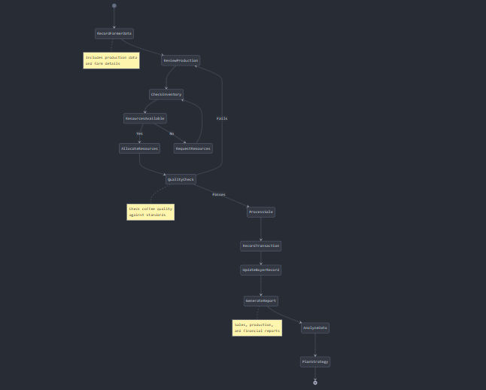

1. Sequence Diagram:
   * Temporal flow of interactions between system components
   * Message exchange between different actors
   * Activity timing and dependencies

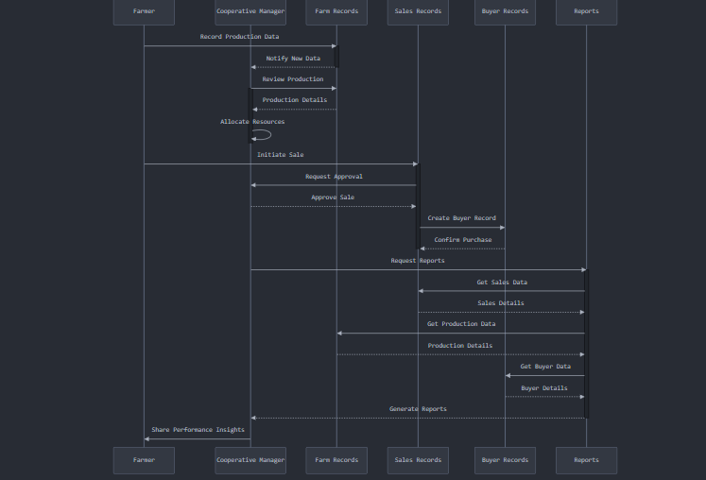

The diagrams together provide a comprehensive view of:

* System structure (Class Diagram)
* Process flow (Activity Diagram)
* Component interactions (Sequence Diagram)

LOGIC MODEL DESIGN

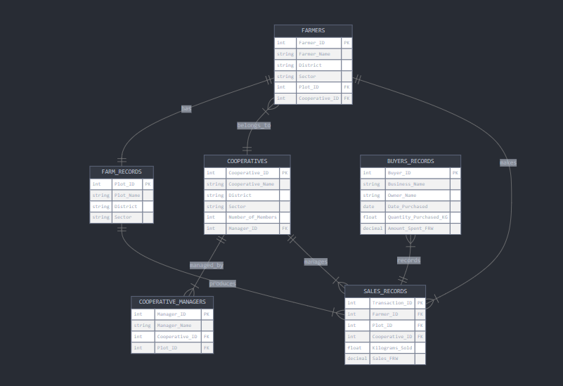

Or

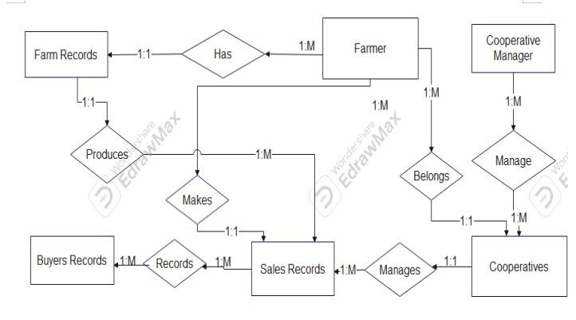

Entities with their attributes:

* FARMERS (PK: Farmer_ID)
* COOPERATIVES (PK: Cooperative_ID)
* COOPERATIVE_MANAGERS (PK: Manager_ID)
* FARM_RECORDS (PK: Plot_ID)
* SALES_RECORDS (PK: Transaction_ID)
* BUYERS_RECORDS (PK: Buyer_ID)

Relationships:

* One-to-One relationships (||--||)
* One-to-Many relationships (||--|{)
* Many-to-One relationships (}|--||)

Key Attributes:

* Primary Keys (PK)
* Foreign Keys (FK)
* Data types for each attribute

Key Features:

* Each FARMER has one FARM_RECORD
* FARMERS belong to one COOPERATIVE
* COOPERATIVES have multiple COOPERATIVE_MANAGERS
* FARMERS can make multiple SALES_RECORDS
* SALES_RECORDS are linked to BUYERS_RECORDS
* All appropriate foreign key relationships are shown